**Lesson 12 Demo 3**

**Integration with SonarQube to scan source code with vulnerabilities**



Steps to be followed:

1. Install SonarQube on Ubuntu VM
2. Log in to Jenkins CI tool and install SonarQube Plugin

**Step 1: Install SonarQube on Ubuntu VM.**

1. Download SonarQube open-source version which does not need any license and can be installed free of cost.

[**https://www.sonarqube.org/downloads/**](https://www.sonarqube.org/downloads/)

1. Download the SonarQube Community Edition zip file and before installing JDK on VM using below command.

**apt update**

**apt install default-jdk**

1. Login to Ubuntu VM and connect with a non-root user to install SonarQube and then extract the downloaded zip file in a separate directory (say zips).
2. Then navigate to the extracted directory (zips) using **cd** command and then change it to **bin/linux-x86-64** directory where you will find the **sonar.sh startup script**.
3. Execute below command to start/stop SonarQube.

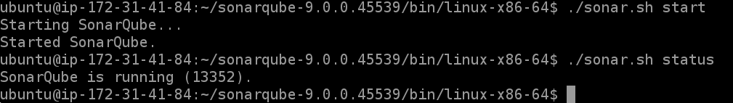

1. Once SonarQube is deployed, access the artifactory using VM ip and 9000 port.
2. Login with SonarQube using below credentials:

Username: admin Password: admin

1. Once SonarQube is fully up and running create a new Token to perform authentication from Jenkins. Navigate to your profile and then the security tab to generate personalized token.

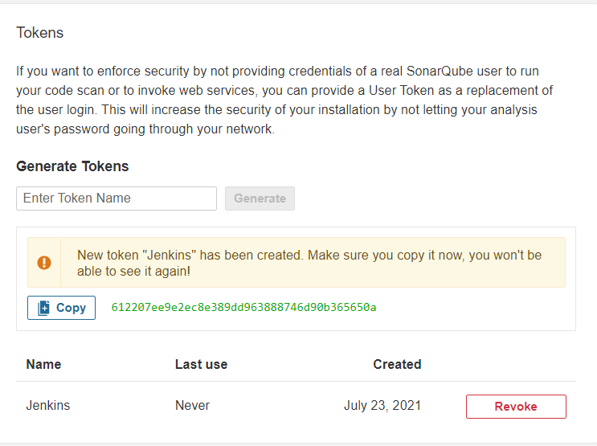

**Step 2: Log in to Jenkins CI tool and install SonarQube Plugin.**

1. Login to Jenkins CI tool with admin user and navigate to Manage Jenkins and Manage Plugins.

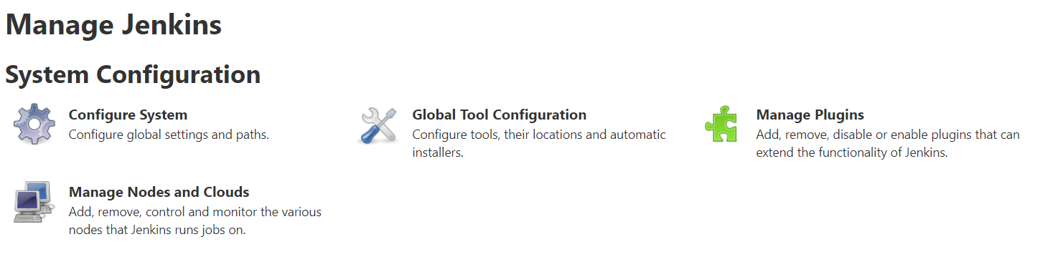

* 1. Then navigate to the Available tab and search for the SonarQube plugin.

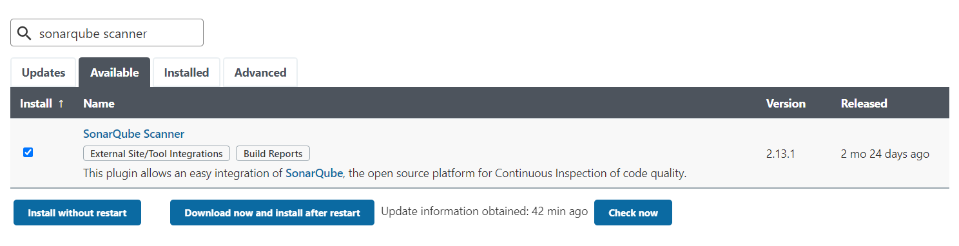

* 1. Create a new credentials with SonarQube token used for Authentication.

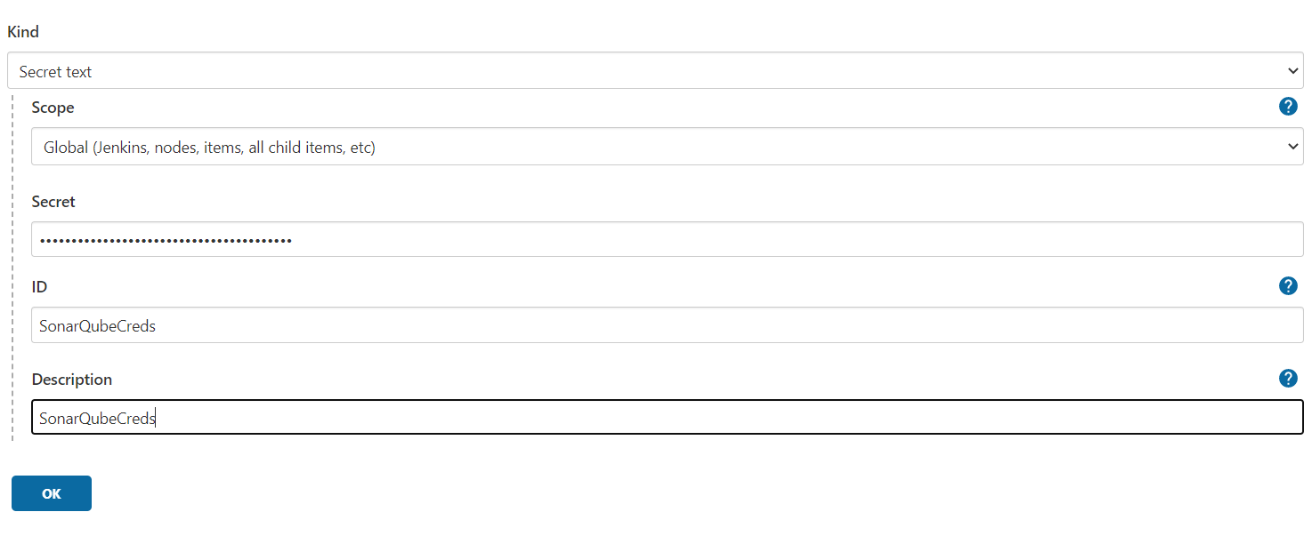

* 1. Now user need to configure artifactory in Jenkins. Login to Manage Jenkins 🡪 Configure System.
  2. Use below screenshot for reference on how to configure SonarQube Server details:

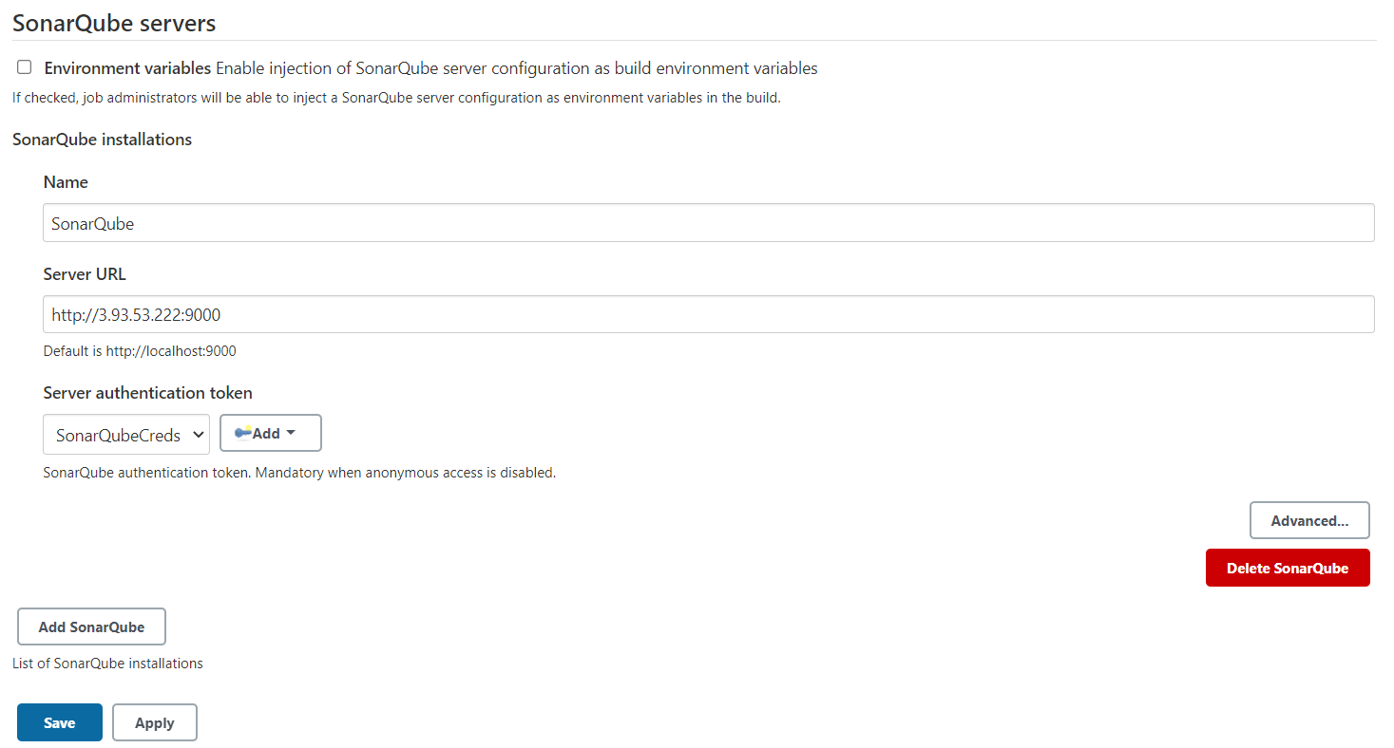

* 1. Once configuration is done save configuration and navigate to Global Tool configuration to add SonarQube Scanner as tool.

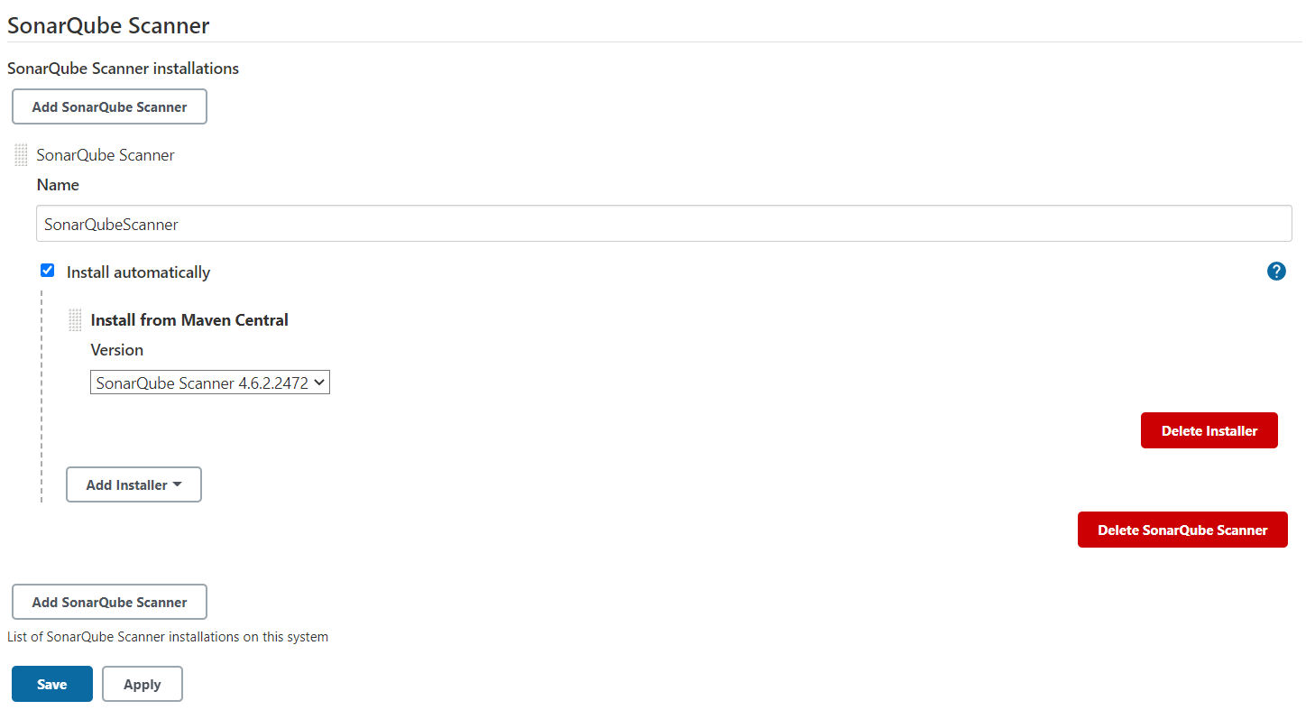

* 1. Once Tool is configured open Freestyle Jenkins job to start integrating SonarQube code scan.
  2. Add Additional Build step as Execute SonarQube Scanner to scan source code.

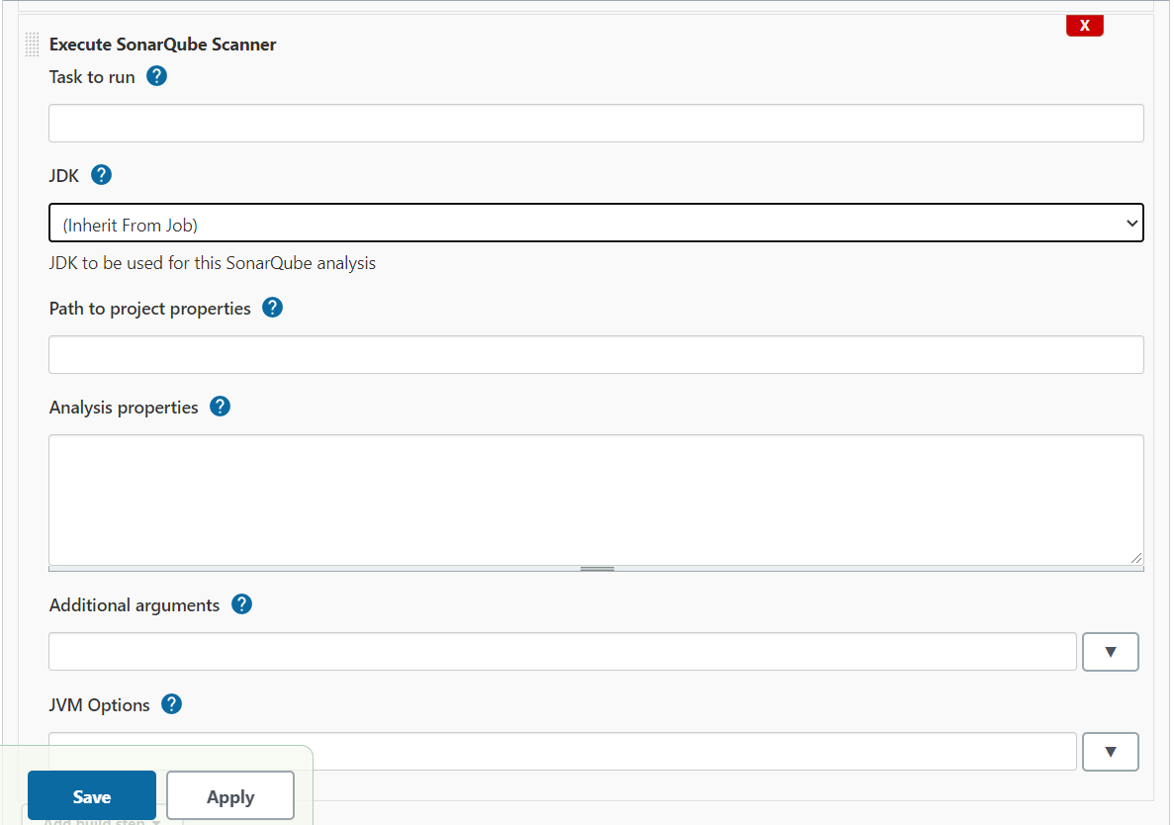

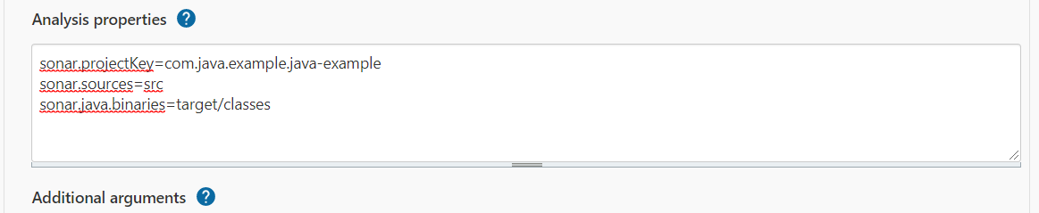

* 1. At last, save the configuration and then trigger the build to implement code scan.

